“White Ribbons Action”

The “White Ribbons Action” was brought in 2022 into being through the cooperation of several associations in Bruges: Anvansa, Nsanga, Pax Christi Brugge, Pax Christi Vlaanderen, Taranta vzw, Vredesactie Brugge, Vredeslicht Brugge, Vredeswijzer vzw, YOT, Vos Vlaamse vredesvereniging, Vredesplatform Brugge, with support from Lokaal Mondiaal Brugge

We are glad that despite our different backgrounds, ideas, and beliefs we united to cooperate in the “White Ribbons Action” for peace.

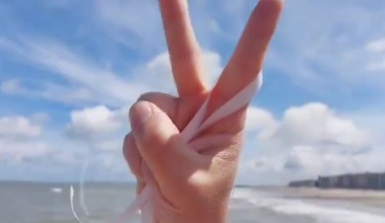

What is "White Ribbon Action?"

With "White ribbon action" the aim is to encourage everyone to hang white ribbons as a sign "For Peace" on your door, car, bike,....

We hang out white ribbons until the wars in Ukraine and Gaza have stopped.

The ultimate goal is Peace - Worldpeace

A peace march from home!
Very easy, very simple, without moving, just from home, by hanging a "white ribbon"

Let's spread white ribbons like a virus! A virus of peace!

Doing nothing is not an option! Let's turn the tide! Or as Pax Ambassades of Peace from the Netherlands says : "Let us start with a new generation, Generation PEACE.

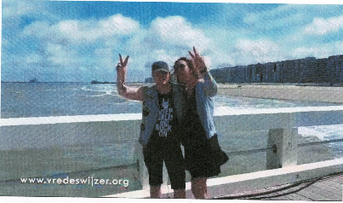

People sometimes say “Love” is a verb. So is “Peace”. Dialogue is the starting point to resolve conflicts. Let's start the dialogue! Let your voice be heard “For Peace”! Let's communicate what we want: “Peace”! Burying our heads in the sand is not a solution! Making ourselves look like helpless victims or powerless is not a solution either. Let us not put the responsibility on someone else. This is not the responsibility of our politicians or other leaders alone, but of all of us. Let us not be passive and stand by helplessly! Let us act! Let us take responsibility “For Peace”! Join the “White Ribbons Action”! Hang up a white ribbon now as a sign “For Peace”! Let your voice be heard!

“Let's unite ourselves for peace!” (Thanks to the College of Europe for this slogan.)
Who?

We invite everyone to join the “White Ribbons Action” regardless of your political or religious beliefs, your gender identity, or your skin colour... We are all human beings and all we want is Peace because every human being has the right to live in a peaceful environment. Our aim is to reach everyone with our “White Ribbons Action” and encourage everyone to hang up white ribbons too. We also encourage schools to participate and to spread the message: “Hang up white ribbons for peace!” from the schools as well because every child has a right to Peace. The idea is to hang up “white ribbons” en masse. Will you also participate?

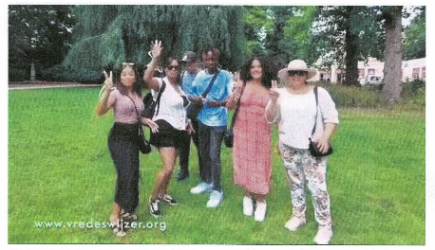

When?

We will launch "White Ribbons Action" symbolically on "The International Day of Peace", September 21.

There is a video "White ribbon action" on our social media and websites. We therefore ask you to share this video as much as possible on various social media channels. We are particularly grateful to Tom Kristiaan, a composer and pianist for donating his licence for his own composed song “A walk through the trees”, the theme song of the “White ribbon action”, to be placed under the video.

We would also like to thank Wim Berteloot who, on “The International Day of Peace”, let the song “A walk through the trees” resound from the Hall Tower over Bruges. It is our intention to spread “White Ribbons” from our city as a sign for peace all over Flanders, Belgium, Europe, and beyond,... and beyond,....

We hope that the cities during end of year not only witness traditional celebrations and customs, but by participating in the White Ribbons action for Peace and effectively hanging White Ribbons also witness a deep desire for global peace and for an end to all wars.

How?

You can easily make white ribbons yourself from old sheets or e.g., a white tablecloth... Let’s choose preferably white ribbons from cotton, linen or another fabric because this is environmentally friendly.

The meaning of the “white ribbon”

The white ribbon refers to the white dove of peace that symbolises peace. The white ribbon also refers to light. If we turn on the light in a dark room, the whole room immediately lights up. In this sometimes gloomy world, let us unite and put up white ribbons (symbolically, rays of light) en masse so that the whole world lights up. We have understood the “For Peace” message of our parents and grandparents, who themselves directly or indirectly experienced war.

War is meaningless

We are convinced: If we collectively demonstrate our Will for Peace, our ultimate goal “Peace – World Peace” will be achieved or at least we will set something in motion to achieve this ultimate goal.

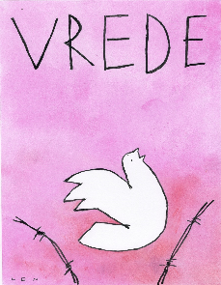

Words of thanks
We are grateful to everyone who helped set up the “White Ribbon Action”.

We owe special thanks to Tom Kristiaan, who composed the song “A walk through the trees”, an almost divine melody, as the theme song for the “White Ribbons Action”.

We would also like to express our gratitude to the city carillonneur, Wim Berteloot, who, on 21 September, the day declared “International Day of Peace” by the United Nations in 1981, made Tom Kristiaan's “White Ribbon Action” theme song resound across the city of Bruges.

We thank Cinema Lumière for playing the “White Ribbon Action” video in its cinema theatres and “De Republiek” to help spread “white ribbons”.

We thank furthermore Brugse Radio and Radio Villabota for spreading our message by radio as well.

Thanks to “Pax Ambassades van Vrede – Vlaardingen” who donated the licence for the very nice drawing on our posters by Len Munnik, artist, illustrator and cartoonist.

There are many more people who have helped, who are not mentioned here, but whom we want to thank as well.

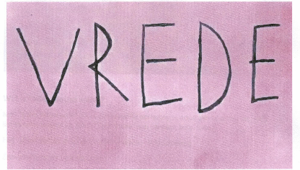

Contacts
Mr. Nieuwinckel Stefan (Director Pax Christi Flanders) Tel 0485/98 74 65
Mr. Steyaert Christophe (Vredesactie Brugge) Tel 0471/03 60 09

Contact point for schools:
Mrs. Van Damme Mira (Local Mondial Brugge) Tel 050/32 42 75

